**Foundation**

SQL

Module 7

Subqueries (part 1) – Query reading

© FDM Group Ltd 2017. All Rights Reserved.

Any unauthorised reproduction or distribution in part  
or in whole will constitute an infringement of copyright.

**Document change and version control**

|  |  |  |  |
| --- | --- | --- | --- |
| **Reason for Change** | **Author** | **Date of Change** | **New Version No** |
| Creation of document | Nick Lawton | 26/06/2017 | v1.0 |
|  |  |  |  |
|  |  |  |  |
|  |  |  |  |
|  |  |  |  |
|  |  |  |  |
|  |  |  |  |
|  |  |  |  |
|  |  |  |  |
|  |  |  |  |
|  |  |  |  |
|  |  |  |  |

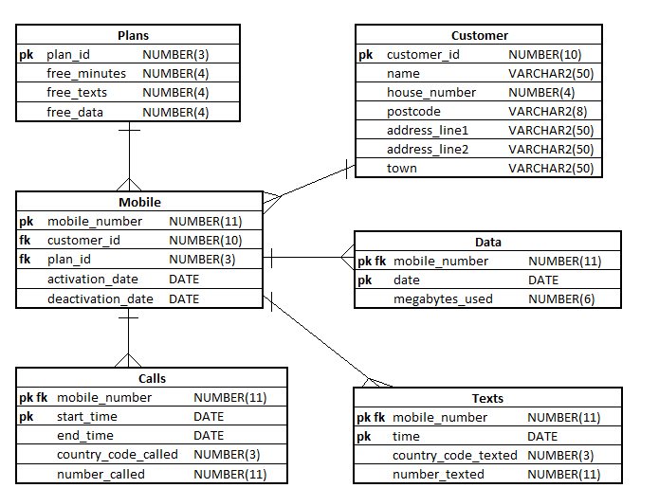

**Exercise 1**

## Describe in simple language what each of the following queries will return:

|  |
| --- |
| **Questions** |
| 1. SELECT mobile_number   FROM mobile  WHERE plan_id IN  (  SELECT plan_id  FROM plans  WHERE free_minutes = 1000  );  The list of mobile numbers that have 1000 free minutes on their plan |
| 1. SELECT mobile_number   FROM mobile  WHERE mobile_number NOT IN  (  SELECT mobile_number  FROM data  );  Show all the mobile numbers that don’t have data |
| 1. SELECT name   FROM customer  WHERE customer_id IN  (  SELECT customer_id  FROM mobile  WHERE deactivation_date IS NOT NULL  );  Show all the customer id for the mobiles that have a deactivate date |